# California: Part Two (Trees of Mystery and Family Reunions)

Places mentioned in this post:

Crescent City, CA

Klamath, CA

Ukiah, CA

Willits, CA

Redwood Valley, CA

Laytonville, CA

Portola, CA

Idaho Falls, ID

Wednesday, August 7th:

We began our morning in Crescent City, CA by packing our things up and then walking across the street to the Fishermen's Restaurant for breakfast. We had an assortment of omelets, French toast, and some mile-high hot chocolate drinks for Abby and Gwen (with sprinkles!).

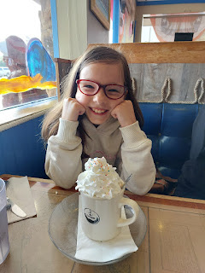

Something we had all been looking forward to was visiting the Trees of Mystery, about 20 minutes south of Crescent City in a place called Klamath. Here, Paul Bunyan and his best friend, Babe, the giant blue ox, welcome you in a cheery voice through the loudspeakers as you pull into the parking lot. I visited here last summer for the first time, and I couldn't wait to bring Amber and the girls with me.

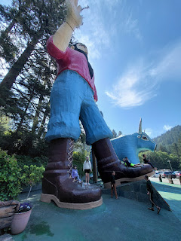

Gwen and Abby loved all the places to pose for a picture . . .

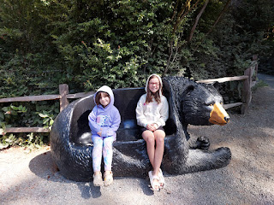

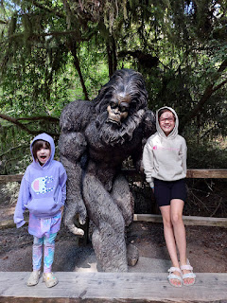

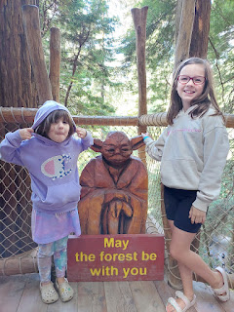

Abby had to summon some bravery for the Sky Trail, which allowed us to walk on several swaying rope bridges amongst the giant redwoods and other trees. She isn't particularly fond of heights, but she plowed right through each section of the "trail" as we made our way from tree to tree.

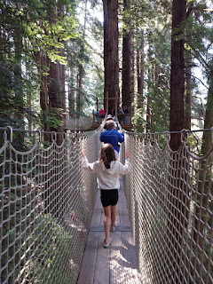

Video of Abby ahead of me on a rope bridge: (6 seconds)

https://photos.app.goo.gl/kbtyAehdyStw6uod9

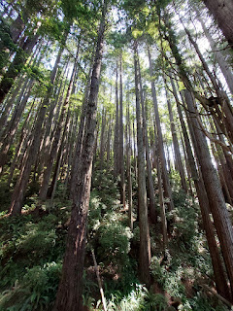

The forest was beautiful and the air was crisp and cool. We all enjoyed wearing hoodies and shorts for a portion of the day before we eventually ended up in the beastly weather of 104 degrees further south.

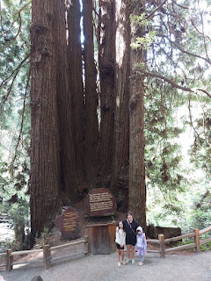

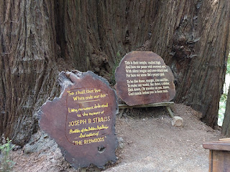

Clockwise from upper left: Amber, Gwen, Me, and Abby

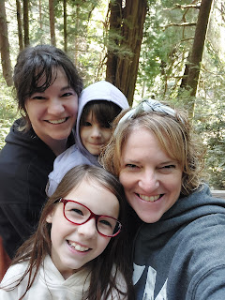

An awkward picture, ha ha. I look like I'm strangling Abby, and Amber looks like she's about to kidnap Gwen by running off down the trail with her.

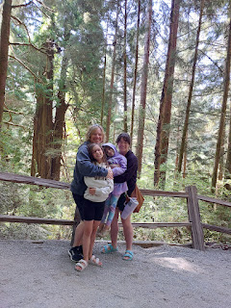

Some interesting fun facts about the trees in this area of Northern California . . .

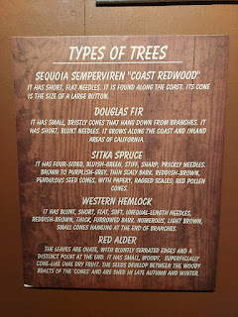

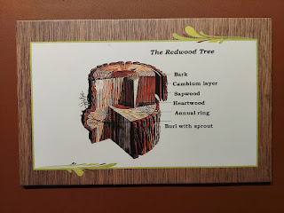

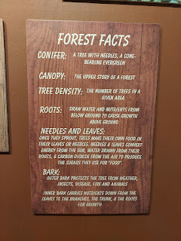

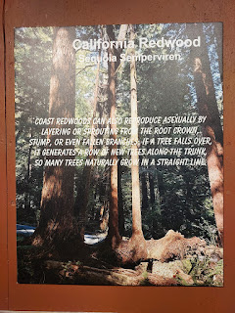

This is the massive "Brotherhood Tree", named so to remind us that we are all one big family and we can be kind to people of all colors, races, religions, etc.

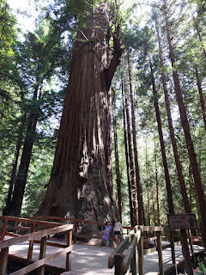

The girls were intrigued by the chainsaw that got stuck in the trunk of this redwood tree . . .

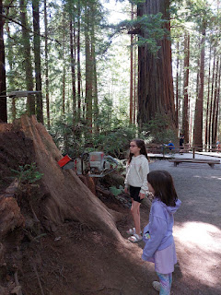

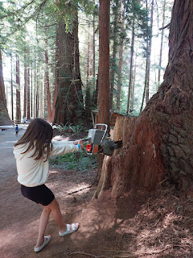

Try as they might, they could not get it out . . .

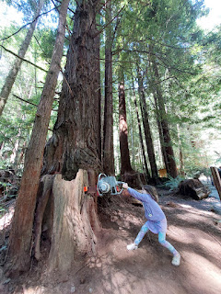

We waited in line for just a little bit (20 minutes or so) to be able to ride the gondola up the mountain to see the tops of the forest canopy.

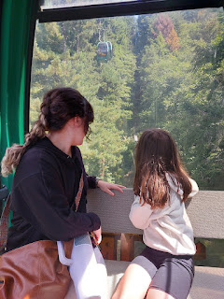

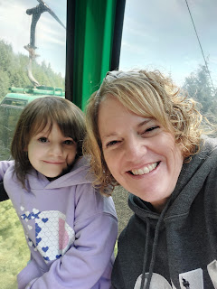

It made my heart happy to bring the girls to one of my favorite places on earth: a redwood forest. I loved to see how they marveled at the stature of the trees, and at how quiet the forest can be.

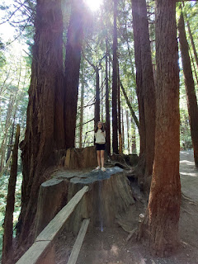

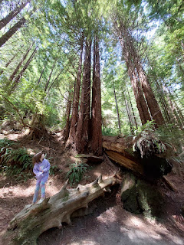

They got a big kick out of the last section of the Trees of Mystery, where a talented chainsaw artist created larger-than-life characters from the world of Paul Bunyan.

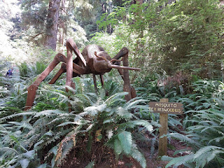

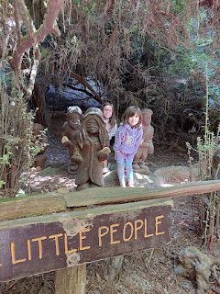

Last year, I think I spent about 1.5 hours when I went here by myself. This year, we spent about 2 hours in total and it felt "just right". We didn't feel rushed, but it also felt like a good amount of time with two young children, and then we were ready to get back on the road to head toward the Great Grandparents.

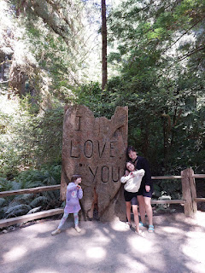

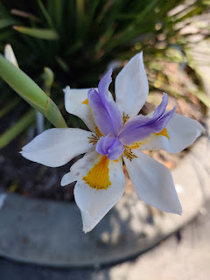

We stopped for lunch in Arcata, CA at the giant Redwood Park, where our family has stopped a few times before, in years past. We picked up some McDonald's and sat on the grass next to the huge playground, where the girls could run around and get some additional wiggles out. They each made some new friends right away, and then a short time later we had to say goodbye.

Our last stop on the drive down to Ukiah was in the Avenue of the Giants. This is a gorgeous and peaceful drive that runs parallel to Hwy 101, with several trailheads and opportunities to experience the majesty of the many sections of redwood forests. My mom had suggested we stop at the southernmost entrance into the Avenue of the Giants, taking Exit 663 South Fork Honeydew, to see the Founders Tree. From the parking lot and several restrooms, it is a short 1/2 mile trek on a flat and wide trail.

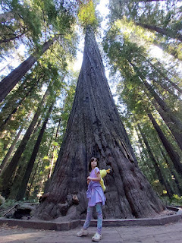

Amber ended up just taking Gwen without me, while I stayed behind with Abby, who had fallen asleep between Arcata and the Avenue of the Giants. I wanted Amber to have the opportunity to see this area because she doesn't come through very often.

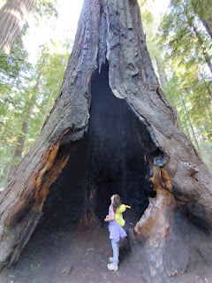

Finally, in the late afternoon, we arrived at our first designated family rendezvouz spot: my Dad's mailbox, next to Hwy 101 north of Willits. When my Dad got out of his car, Amber ran over to give him a hug and they both started to cry. XOXO How precious.

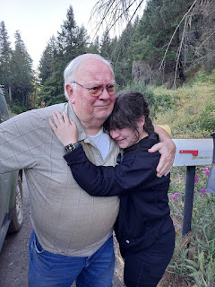

We visited for a little while, with Gwen and Great Grandpa John swapping several "Dad Jokes" back and forth, entertaining all of us. Before we left, we propped my phone up next to one of the mailboxes so we could get a group selfie. We ended up getting a great photo on the first try!

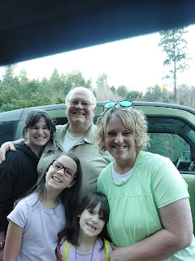

I'm not sure if this was a weed or not, but the blossoms were sure pretty behind the mailboxes . . .

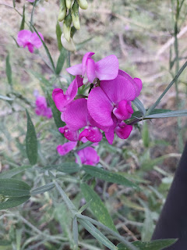

We arrived safely at my mom's house a short time later, joyful to be out of the car and onto dry land at last. Mom did a great job showing the girls around and making them feel welcome. She had been preparing and looking forward to them coming for quite some time. Abby and Gwen settled right in and we all slept really well that night, in spite of the heat. Thank goodness Ukiah cools off at night in the summer.

Thursday, August 8th:

The next morning, while I left Amber and the girls to hang out with Grandma Linda (my mom), I drove up to Willits to meet my Dad and accompany him to an important doctor visit. He had recently had a stroke, with a variety of symptoms, and this was his first follow-up to discuss everything. His wife, my step-mom Michelle, was out of state visiting her elderly mother in Oklahoma, and my dad didn't have anyone else to go with him to this appointment. So Amber and I bumped up our schedule to get down to Ukiah/Willits in time, and then I went with him and took notes.

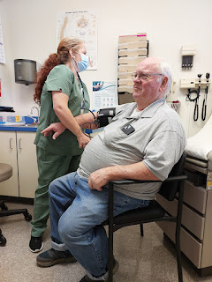

After the appointment was over, Amber drove up with Abby and Gwen to meet us in Willits for lunch at Dad's favorite Mexican restaurant, El Chicano, on Main Street. It was delicious!

When I returned down to Ukiah later in the afternoon, I was able to give my mom the apron I had made for her just before we left Idaho Falls. I used her other apron (it was completely worn out from all the good use she got out of it) as my template and then I knew it would fit her perfectly. She loved it and then wore it every day the whole time we were there! This is a good way to know that the recipient enjoyed your gift . . . :)

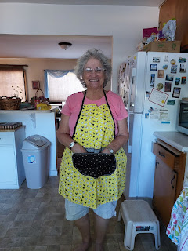

Late that night, my sister, Melanie and her son, Caleb (22) arrived from Gilbert, AZ to spend a few days with us, too.

Friday, August 9th

: What an incredible day this was!! My mom, Melanie, Caleb, Amber, and I all drove down to the Feather River Temple in Yuba City to participate in some sacred ordinances together.

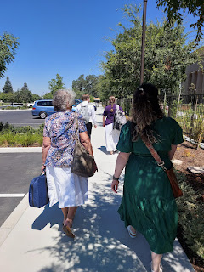

As members of The Church of Jesus Christ of Latter-day Saints, we believe in the eternal nature of the family and the sacred sealing power of the priesthood, which connects families for eternity. We believe that what is bound on earth can also be bound in heaven, and temples are where we take part in this beautiful process.

Back row: Melanie (my sister), Linda (mom), Me, and Amber (my daughter)

Front: Caleb (my nephew)

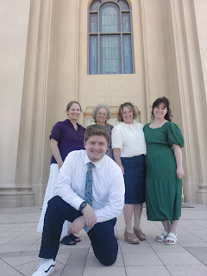

My mother was the first in her family to be baptized into The Church of Jesus Christ of Latter-day Saints back in 1977/78, and being the only one thus far to have done so, she also yearned to be sealed to her parents and to a few other loved ones who have already departed this life.

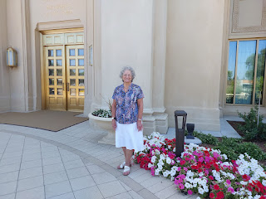

On this special day, she was able to be sealed to her parents, which brought such joy to her heart!! Her mother (Grandma Doris) was also able to be sealed to her parents (Christina and Leon), with us acting as "proxy" in the sealing room of the temple. My mother's older brother, Ronnie - who died many years ago at 18 years old - was also able to be sealed to his parents, too. We felt so much love in the room that day. It was tangible, it was palpable, it was joyous, it was beautiful. We felt like Ronnie was there with us, and Grandma Doris, and her parents. We felt as if they wanted us all to know that they were grateful that we took the time to make all of this happen, and that - more importantly - they were happy to be sealed as parents and children for eternity.

On the Church of Jesus Christ website, it explains:

"

The ordinance of sealing children to parents is performed only in the temple. To extend these blessings to all people, we can also perform proxy sealings for those who have died. In this way, all families may be together forever.

"The promise that our families can be together after death gives more meaning in life. It encourages us to be faithful and loyal. It improves and enriches our family relationships. It helps us find joy and hope as we deal with the challenges of life. And knowing that we can be together again brings comfort and peace as we deal with the suffering or death of loved ones.

"The sealing ordinance is a gift from God to His children. It enables us to return to live with Him and all of our loved ones forever. It offers marvelous blessings for this life and the next. It is a constant reminder that families are central to God’s plan and to our happiness here and in eternity

."

To learn more:

https://www.churchofjesuschrist.org/temples/what-happens-in-a-temple-sealing?lang=eng

Me, Mom, and Melanie . . .

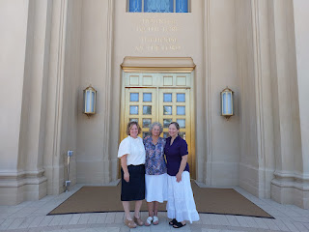

After we took some time to admire and quietly discuss many of the exquisite paintings that hang on the walls of the temple, we left and went in search of food. My mom suggested Chili's, where she had had a fabulous salad recently when she came down to Yuba City with some friends.

As we pulled into the parking lot, there were a few chickens and a rooster randomly walking around next to our car . . . it was both curious and hilarious at the same time!

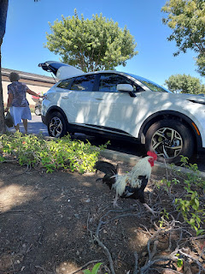

It makes one want to quip: Why did the chicken cross the road?

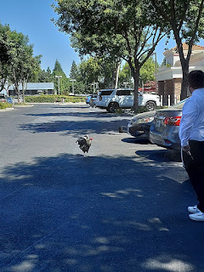

Melanie did all the driving that day, bless her long-haul truck driving heart! We got home after 9.5 hours of being gone, and found Abby and Gwen contentedly watching a movie with their babysitter, Naomi. They had had a great day, too.

My brother, Ryan, showed up with his 3 kids a few minutes after we arrived, and we enjoyed letting the cousins get to know each other. Abby and Lily are both 9 years old, while Gwen and Blake will both be 7 this year (once Gwen has her birthday in October).

Lily, Blake, and Abby, with Ryan's dog Cooper . . .

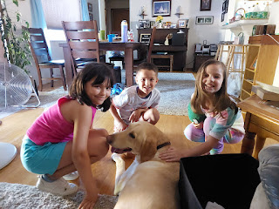

Emily (almost 11) took to Gwen immediately, and wanted to carry her around everywhere. Gwen didn't mind one little bit.

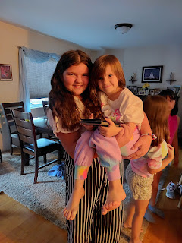

Ryan is a very dutiful and wonderful father. Emily was born with a heart defect that requires medication every 12 hours. He also simultaneously and carefully listens to her heartbeat to record her pulse and then notes if there are any abnormalities.

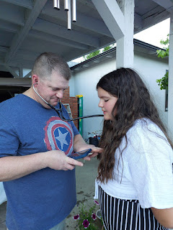

Adventures around the backyard, with Emily carrying Gwen . . .

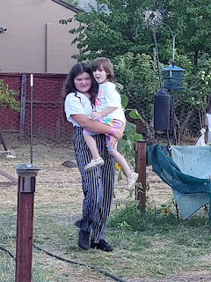

Here, they are all lined up - oldest to youngest from right to left.

Emily, Abby, Lily, Blake, and Gwen

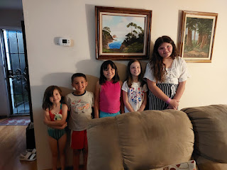

Saturday, August 10th:

After a cousins sleepover with Emily and Lily joining us, it was a little crazy getting us all ready the next morning. But it was all worth it, knowing that they all got to be together. We got everyone up, fed, dressed, and a lunch packed for each person, all by 9:00 a.m. The reason for the hurry was because this was the day of our newly rejuvenated Rawles Reunion/Family Picnic!

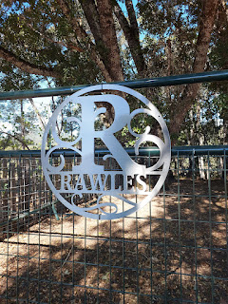

My dad's maternal line, the Rawles family, started having an annual family reunion several decades ago. They had one every year for many, many years before Covid hit in 2020. It took a few years to garner enough interest and to get that rusty wheel turning again, but surprisingly this year we had a pretty big group that showed up!

We met at Tom and Kathy Rawles' ranch (my 2nd cousins) at the north end of Ukiah, bordering Redwood Valley. They have a lot of acreage that has been in the family for many generations now, starting with my Great Grandpa E.C. "Bob" Rawles. There are barns and other outbuildings, a pen full of bleating goats, and a lovely home surrounded by several shade trees. It was the perfect place to meet together as the Rawles Family. My dad remembers spending a lot of time on this ranch as a young boy. He would hunt and explore and had some great adventures here.

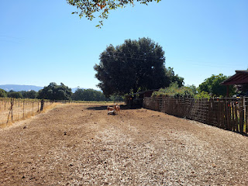

Newly acquainted and cuter-than-cute cousins: Abby, Lily, Emily and Gwen. (Note: They are 1st cousins, once removed. Emily, Lily and Blake are 1st cousins to my kids - Amber, Jake, and Benson)

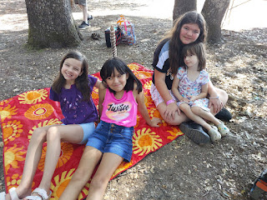

Ryan, my Dad, and Caleb . . . (and Cooper)

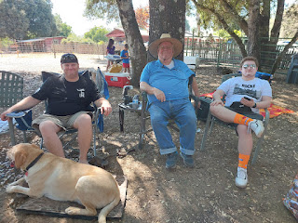

The kids were very resourceful in finding ways to entertain themselves. There wasn't a lot for them to do as far as games or activities, so they made something up.

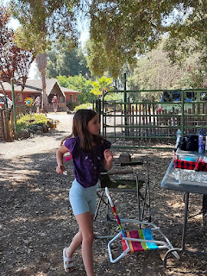

They created a storyline where Blake had mysteriously disappeared, possibly even murdered. They needed to interview/interrogate some key people to find out whodunnit. Gwen was an excellent interviewer.

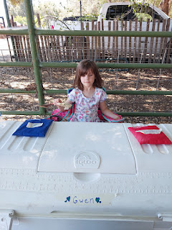

She'd ask questions like, "When was the last time you saw Blake?" "What time did you last see him?" "What have you been doing since then?"

When she had enough information to make an "informed" decision, she'd whack her little homemade gavel to administer the judgment. She might whack it on the blue pouch on her right that said "free to go", or she might whack it on the red pouch on her left that said, "suspect". If you were considered to be a suspect, you had to stick around for another potential round of questioning. Yikes . . . lol.

Lily liked to be the camera person, recording various interviews, including my own: (1 minute)

https://photos.app.goo.gl/DMtLJoJaD7BAMq1W8

Abby, with some feather decor at the reunion . . .

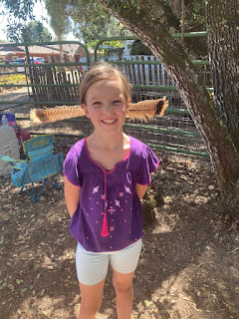

I visited nonstop for about 4 hours with almost everyone! We had a group photo in front of the barn (which I'm patiently waiting for Ryan to edit), we went around the circle to introduce everyone and share a little tidbit about us, we brought our own lunches to eat, and it was all so lovely.

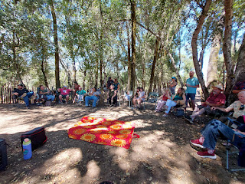

When we left around 2:00 p.m., I drove my Dad, Melanie, and Caleb a little further north to visit the Laytonville Cemetery. We had a brand new headstone to check out . . .

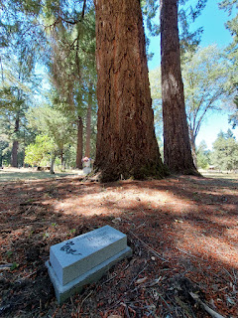

I mentioned this last week, but my 2nd great grandfather, James C. Baugh, has never had a headstone until now. Scott and I felt it was important and so we set out to make it happen this summer. Roughly $700 later, we had a wonderful experience there. I asked everyone in the car if we could be silent as we pulled into the cemetery, which they respectfully responded to.

I drove over to the exact spot that I remembered from the last couple of times I've been there. I got out and walked over to the new headstone and just stood there for a few minutes in silence. I wanted to FEEL something. I had prayed earlier that I could feel something when we came.

It finally happened. After a couple minutes of standing there silently, I felt a connection to my great-great grandfather, James Baugh. I felt him saying to me, "Thank you." And I felt a glimmer of love from him. This was a big deal, especially when there is the possibility that he was a hooligan, or perhaps even a criminal. It takes a lot to get through to a hardened heart, even if he's been in heaven for a while and has had some time to think about his life and Jesus and the scope of eternity since 1868. The main thing is that he came through and I felt a connection to him. For the very first time.

I've been studying and researching his roots for about 20 years now, and I've never felt anything from him. This is one reason why I wanted to get a headstone made for him. I guess I figured that maybe, just maybe, if I did something for him - to honor him and show that I love him, then maybe, just maybe he might be willing to help me out in return. Maybe I'll catch a break in my research in the coming months and I'll finally figure out who his parents are and where he came from. And I'll know exactly who helped me when it does eventually happen.

Our hands: Dad (upper left corner), Melanie (top), Me (right), and Caleb (bottom left)

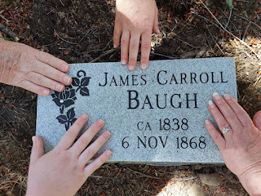

We also visited the graves of my great grandparents, Sarah Jane Baugh (James' oldest child) and her husband, William Alvin Snider.

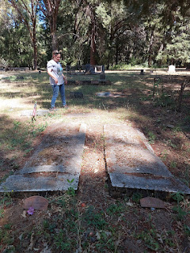

I had intended to be brave and attend my "off-year" high school class reunion. It was scheduled for that same evening. Someone didn't want to wait another 5 years for our 40th class reunion, so they arranged for a 35th year reunion in Ukiah. I knew about it a few months in advance because of a notification on Facebook. And I was in turmoil . . .

I haven't attended a single reunion so far, and I typically just use my silent default excuse of - "Well, I live far away and therefore I can't make it." But this time was different because I would actually BE in Ukiah on the weekend of said event!!! Oh, the dread . . .

I still have some anxiety about the idea of seeing people from high school because I got pregnant during my senior year and ended up giving a daughter away through adoption. I felt (and heard) the whispers around me when I was 17 years old, and I felt horrible inside. It was a first-timer accident and people were talking about me like I was a complete and utter tramp. Well, not everyone. But enough that it felt like it was everyone.

So why would I want to return to that same group of people? Because, as my older sister Charmaine gently said, "People change". She felt that it could be very healing for me to see that people grow up, they mature, they make something of themselves, they become more kind and more forgiving. Life has a way of putting things into perspective. My son, Jacob, also told me that it would be good for my classmates to see that I had also changed, and become something, and made something great out of my life. I came out of the ashes of a teenage pregnancy and became a good mom, a loving wife, a fun grandma, and I've had an incredibly amazing marriage for 32 years. He said, "You don't need to be braggy. You just show up as yourself and they will see and understand."

So I was willing to go. I didn't want to go, but I was willing to go. I even had the perfect outfit picked out. I brought it home in my suitcase from Italy. I transported it in another suitcase as I drove out to Oregon and California. I hung it up in my closet so it wouldn't get wrinkly once I got to my mom's house. I was prepared. And Amber was coming as my date. She would be my support and my buddy. I was planning to go for maybe an hour, and then if I wanted to leave, I could check the whole thing off my list and leave.

But what happened instead was that I had two full days in a row of uplifting, joyous, fulfilling, beautiful time with family - both seen and unseen. I was all tuckered out by the time we got home from the Laytonville Cemetery. Amber had a pretty uncomfortable sore throat and she was super tired, too. I decided right then and there that I wouldn't go. And it felt good inside once the decision was made.

I wasn't running away - because I

was

willing and I

was

prepared. Deep down inside, however, I was so filled to the brim with spiritual things and important things and meaningful things. And going to the reunion just felt hollow. Shallow. Not so meaningful. And I didn't have enough energy to engage in any more conversations with total strangers.

Hi. I'm Michele. And who are you?

Oh . . . wow. You look great.

Are you married? Oh - divorced, huh. I'm so sorry.

Do you have kids? Three, eh? That's cool. Me, too!

Oh - your oldest is an intern at the White House? Very cool.

And your middle child is the CEO of their own company? Wow. That's impressive.

And your youngest is working as a diplomat in the Middle East? My goodness. You must be so proud.

I didn't want to pack my exhausted brain with a bunch of details that I didn't have room for in the first place. So, once I decided that I would stay home and just be with the family, that felt like the right thing to do. And I didn't regret my decision. I was at peace with it.

If the opportunity arises someday down the road, I might consider going. But only if I'm already going to be in Ukiah at the same time. I'm not going to make a special trip just for a class reunion. And in the meantime, I will continue doing what I'm doing. I will hold my head high and try to make a difference in this world. And I will be confident in the woman I have become. And that will be enough. Because I am enough.

We ended up taking Abby and Gwen to the park for a little while that same evening. We let them run around and make some new friends on the playground while the rest of us sat around and visited on a park bench. It was very relaxing and I was grateful to be surrounded by family and their love.

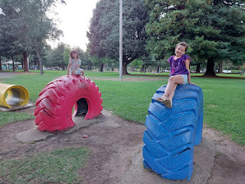

Caleb and my mom, swinging to their hearts' content . . .

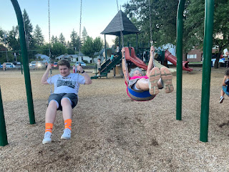

Amber and I took the girls to get some ice cream at Baskin Robbins before we went home. And as we drove down Perkins Street, we passed the Sports Attic 2, the very same venue where my class reunion was being held. I saw less than 10 cars in the parking lot . . . and I didn't feel bad that I didn't go.

Before bed that night, I began looking through some boxes of stuff that my mom had saved for me. Here is a gem that I found, a poem that I sent to my Grandma Doris when I was a young girl. I'm not sure exactly how old I was, and I'm not sure that I actually wrote this. But maybe I did . . . or maybe I copied it from a book or something?? (click photos below to enlarge)

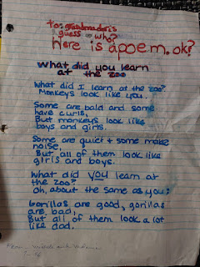

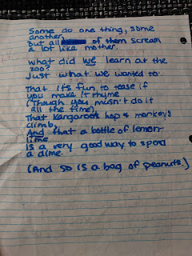

Sunday, August 11th:

Sweet hugs were exchanged between Amber and Grandma Linda before she and the girls left . . . Sadly, we didn't think to get pictures of Grandma Linda and Abby and Gwen. How dreadfully sad. But we know they had fun together! They bonded over making homemade play-doh together and visiting and other activities.

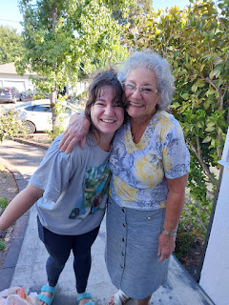

A cute selfie of Melanie and me before they left on Sunday afternoon to fly back to Arizona . . .

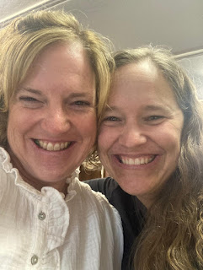

Monday, August 12th:

I helped my mom to clean the bathrooms and tidy up after everyone had left. We went into town later to mail a package and visit the Mendocino Book Co. - my favorite book store in the whole world. I spent quite a bit of money there, but I don't regret it.

We drove past our old home on Sanford Ranch Road, the one we moved into when I was about 13 years old. Even though the front yard is dry and dead, the property still looked very nice. This is all too common in CA because there's never enough water, it seems. But the house looks really good and it brought back some happy memories to see it again. I do miss having my sister, Charmaine, living in there, though. Anytime I come back to Ukiah to visit family, I'm always sad that she's not there anymore. She lives in San Diego now, so that's a whole separate visit that I have to figure out.

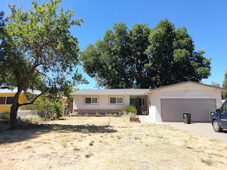

That evening, my mom and I went for a nice long walk around the track where I used to attend Pomolita Middle School (6-8 grades). I remember running the 50-yard dash on this VERY TRACK many, MANY years ago. The evening was cool and I was glad I had a hoodie on. After a while, Mom sat down on a bench to rest. That's when I did a couple of extra laps by myself, and I even RAN. That felt really good.

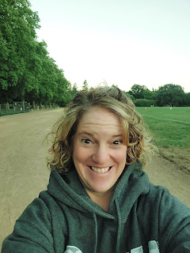

Tuesday, August 13th:

I had a fun day planned out to visit with a couple of friends. First, I drove a little north of town to see my friend, Jill Millward. I met her when I was 6 years old and we've been friends ever since. She was one of my very first friends at church, since my parents were taught by the missionaries and we started attending around that same time. She is also a very talented artist and has a huge art studio in her garage. She offered me the chance to do some ceramic work, and I was excited to learn from her.

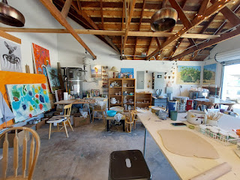

She had two stations set up before I got there, with a blob of recycled pottery clay for each of us.

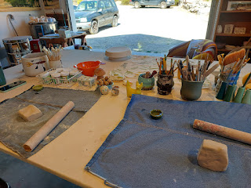

We alternated between two projects: a large plate/platter and a cute little ceramic cat. We started on the plates first, rolling the clay out and then draping it over a finished ceramic cake stand, just to help it hold its shape while it dried in the sun for a few minutes. We jumped over to work on the cat project, and then back to the plates before they dried too much and cracked.

Jill showed me first how to run the wheel with the foot pedal and how to hold the knife steady while the plate spins so I could trim a nice straight line to form the edges.

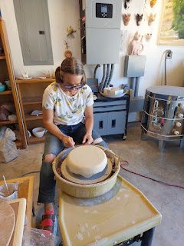

And then it was my turn. Notice my t-shirt . . . I didn't know how messy this pottery adventure would be, and I didn't bring clothes out to CA that were okay to get ruined. So I went to Walmart the day before and found a Ukiah HS Wildcats t-shirt in the men's section and voila! Perfect. (FYI: I was the high school mascot during my junior year in high school. I was Willie the Wildcat.)

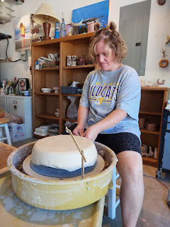

Jill took a video while I was slowly spinning the wheel and cutting the edge of my plate: (16 seconds)

https://photos.app.goo.gl/qxYeMZpCnwi3Gi987

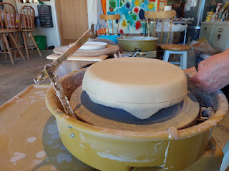

Her hairless cat, Ken, hung out with us while we worked and listened to 70's classic rock. LOL

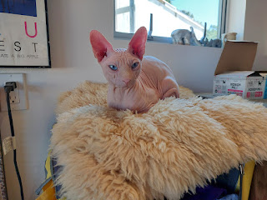

Her studio is beautiful and is playfully organized and arranged. It was a very happy space and I was glad I was there.

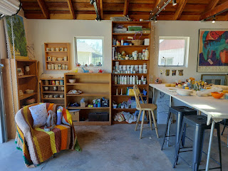

The projects we worked on take patience and several steps before they will eventually be finished. She does have a kiln, so she'll go ahead and fire the pieces for me. Next summer, I'll return and finish them up hopefully with paint and glaze, etc.

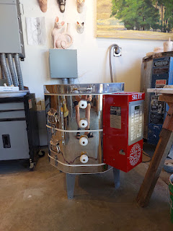

She's made several ceramic cats recently, though now she's on a dinosaur kick.

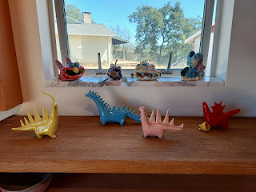

On the left is a cute yellow cat that Jill has already made. It's been fired and painted. On the right is my cat, slowly taking shape . . .

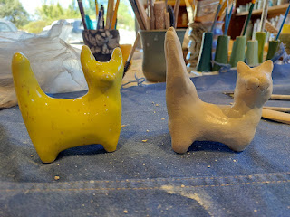

Eyes and whiskers were then added in . . .

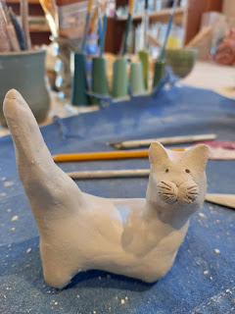

My plate, complete with an upside down "M" stamp, that will be right side up when the plate is finished. I etched in my name on the bottom, too.

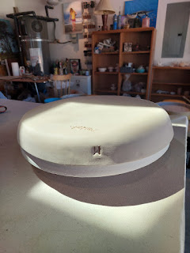

Here is a plate that Jill's cousin finished recently, which gives me an idea of what mine will look like when it's eventually done, too. I love the flecks in the glaze.

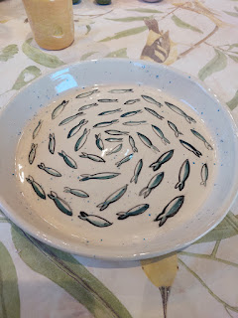

Me and Jill - friends for 47 years . . .

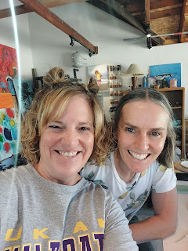

I wanted to buy one of her darling cat mugs, even though I'm not a "cat person". They're just so cute! But she insisted on giving me one for free, and I got to choose which one I wanted. I chose this one because I liked the shape of it and the faces on it. She said the mugs are microwave safe and food safe, too.

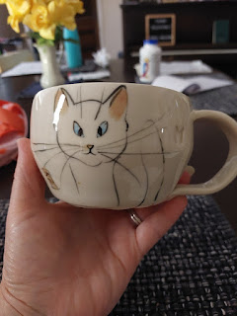

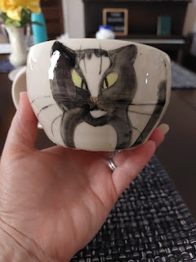

That same afternoon, I went to see my friend, Jenn Caudle. We visited about our families and everything going on in our lives, and then we jumped into some family history. We did some research together and I helped her figure a few things out and point her in a direction for some next steps on her tree. She is a great detective and has a keen mind and a good eye for details. It was fun to see her again!

That evening, Mom and I went to place some flowers on a few graves at the Ukiah Cemetery, something we had tried to do a couple of times before but the front gate was always locked and we couldn't get in until now. We hadn't noticed the unlocked walk-in gate to the left of the main gate . . . but finally we got in and could go see Grandma Doris' grave (my first time) and Uncle Ronnie, along with Grandma Zoe and Grandpa John Snider (my dad's parents).

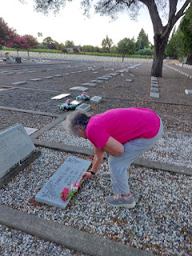

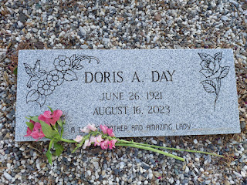

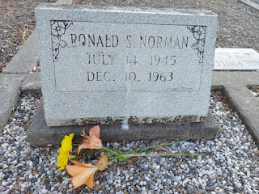

Their headstones are in the row right next to Frank Zeek Elementary School and the playground slides that are right next to the fence.

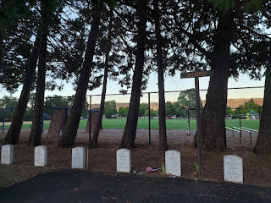

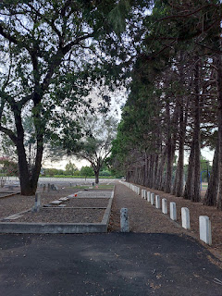

I got a kick out of the setup that someone has left to honor their loved one at one of the graves . . .

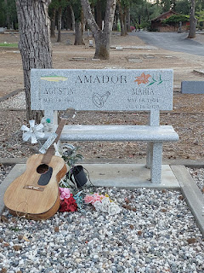

There was a momma deer and a baby deer wandering around in the cemetery close to where we walked. I bet they were looking for some fresh flowers to nibble . . .

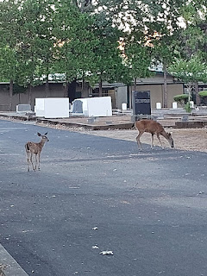

Video of the deer: (8 seconds)

https://photos.app.goo.gl/VVo4dbE7kuoVeX17A

It took us a little while to find Grandma Zoe's and Grandpa John's shared headstone. I knew I was in the right vicinity, but I wasn't seeing it. I opened the app "FindaGrave," because a few years ago I pinned the location of several family members' headstones in the Ukiah Cemetery using this same app. Now, I was able to navigate to their headstone right away, and I hollered over to Mom who was a little ways away looking in a different area. This is the headstone (below), looking south toward Low Gap Road.

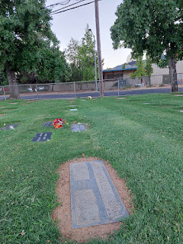

Gosh, I miss Grandma Zoe. She was a lovely lady. I feel her presence the most, in varying situations. Sometimes, I feel her nearby when I'm doing a quiet task like washing the dishes. Another time, I felt her come sit next to me for almost an hour while I worked on some embroidery and sewing details for a "Quiet Book" project I was making for my grandchildren. She used to make handmade dolls and did lots of embroidery work, too, so I'm sure she was interested in what I was doing. :)

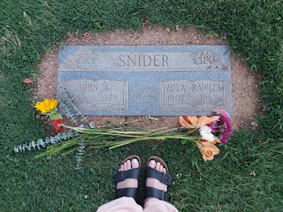

Wednesday, August 14th:

I met my Dad and Michelle at their old house in Willits. The Margie Drive house had been rented out for a long time to some renters that didn't take care of the place AT ALL. The renters finally moved out and then the long road began of gutting the house and putting it all back together again. It's been two years now (I think) with lots of hard work by my Dad and step-mom, who are also getting up there in years. Last summer, I helped to lay some brick in front of the house under the living room window, among other projects. It feels so good to help them whenever I can.

Now, they are on the HOME STRETCH to get it listed for sale. Yippie skippie!

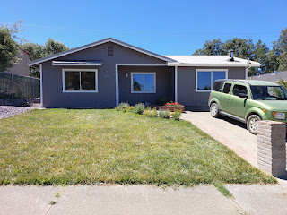

At the tail end of this massive project is the cleaning up part. Michelle asked if I could clean the master bathroom for starters. I emptied out any project supplies and/or trash, and then got it all nice and sparkly. I had to kill a couple of spiders in the process, ha ha.

Before:

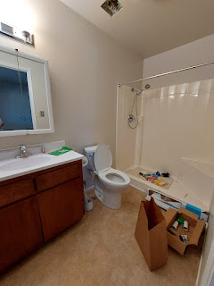

After:

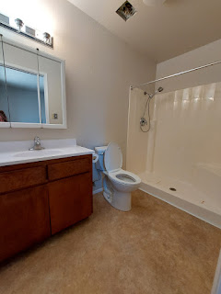

Next, I cleaned all of the windows inside and out, using the old-fashioned method of 2 buckets, a scrubbie sponge, a rag, and a squeegee. Bucket #1 had a little bit of dish soap with the scrubbie sponge. After I first got rid of any spider webs, I scrubbed each window pane. Bucket #2 had fresh water and a rag to wipe the window down and get the suds off. Lastly, the squeegee got it all sparkly and shiny.

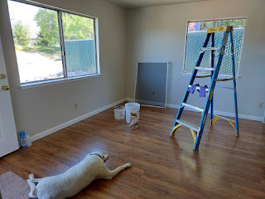

While my dad worked on some smaller (but still important) projects that allowed him to sit down, Michelle worked on getting stuff cleared out of the house - tools, building supplies, etc. that aren't needed at this job site anymore. The more the house got emptied out, the more excited we all got. It really did feel like they are on the verge of being done there!

We picked up the usual Taco Bell for lunch and worked all day until about 4:00, when we stopped to just sit and visit for an hour until I needed to leave. I absolutely LOVE working on projects like this and I seriously wish that I lived closer so I could do some construction work more regularly.

Hopefully, next summer I can haul my husband out there with me, too, so we can have an extra set of hands that connect to a really smart brain. He's worked on a whole smattering of home-improvement projects over the years: pouring a cement patio, building a deck with steep stairs, vinyl siding, replacing windows, installing hardwood floors, and redoing all 3 bathrooms in our current home from the sub-floor all the way up to amazing. When you marry a mathematician, you also get a really smart handyman!!

After I hugged my Dad and Michelle goodbye, I drove home to my mom's house and got all freshened up so we could go out to dinner. She chose to take me to Patrona in Ukiah, located in the very cute downtown area. This was an early birthday dinner, and it was 100% delicious.

I ordered the corn chowder with bacon bits and green onions, plus some battered shrimp in lettuce wraps.



I need to find a way to make a DIY version of those tasty shrimpies. They were crispy on the outside, with a light Thai chili glaze. I didn't need the dipping sauce, which was a bit too spicy for me. But I wish I had two stomachs so I could have eaten more of the shrimp and lettuce wraps!

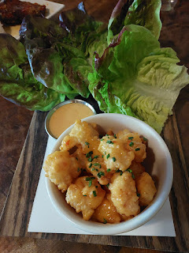

Because we were celebrating my birthday, even though it's not until August 27th, the server brought us out a special dessert to share: Creme brulee. Yum!!

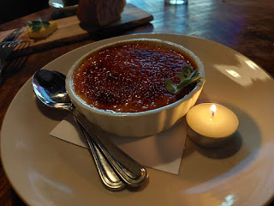

Our darling server, Creedence, even helped us to get a picture outside after we finished our meal.

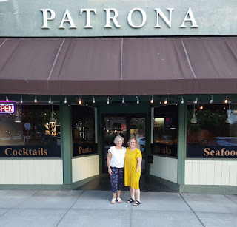

Thanks, Mom, for a delightful dinner and your cheerful company!

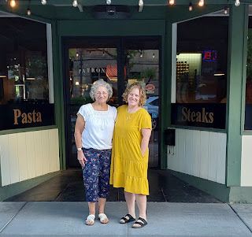

Thursday, August 15th:

I sorted through a few more things in the boxes that my mom has been trying to organize, each holding loads of memorabilia from Grandma Doris' life. I found a beautiful poem that my mom had written for me years ago when I was young . . . (click photo to enlarge)

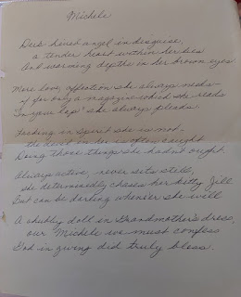

And a hilariously sarcastic list of rules for a cat who has a house to "run": (click to enlarge)

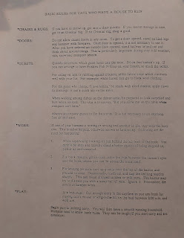

I chose a few things to haul home to Idaho with me, including several groups of photos to scan and some special silverware that used to belong to my great-grandmother, Christina Miller Jones (Grandma Doris' mother). My mom cried as she looked through them one last time, thoroughly assuring me that it was okay for me to take them because she knew they would be in a good home. She was crying happy tears because she remembered having meals with her Grandma Christina and Grandpa Leon where these very same utensils were used. Those were some beautiful memories for her.

I accompanied my mom to the FamilySearch Center in Ukiah for her weekly service assignment there. We spent two hours searching for records for some of her late husband Frank's grandparents who had come from Ireland. I haven't spent much time looking into Irish records before, so this was a good time to start! We sat side-by-side and worked methodically to find a couple of sources that we could attach before it was "quittin' time". There's really never a solid "quitting time" when it comes to family history. I have often said, "Family history is like the best suspense novel you've ever read . . . with NO ENDING!" But sometimes, you just have to walk away because life has other demands on your time, too. (This includes eating and sleeping)

I went over to see my friend, Jenn, one more time, and to pay her teenage daughter for some darling sewing projects that she's going to work on for me. She is making all sorts of things, including baby bibs, bowl covers, quilts, etc. She's been doing very well in selling her crafts over the summer. Good for her! She's a very ambitious young lady and I'm excited to see where her talents take her in the coming  years.

Me and Jenn . . .

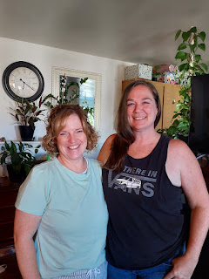

I also stopped by my former brother-in-law's house to pick up a few more things that got left behind when I brought my niece, Mari, up to Idaho recently. Her father, Bernardo, gave me the cutest gift!! He had made me a little squirrel picnic table - complete with its own UMBRELLA!!

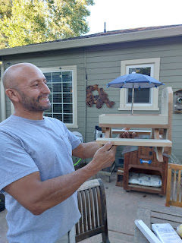

You can fill up the top with sunflower seeds, or nuts, or whatever, and then let the feast begin! There's even a place to mount the picnic table to a tree or a deck or whatever. How absolutely CUTE!!

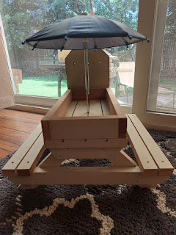

Before tucking in for the night, my mom and I went for one last walk, this time in the vicinity of her neighborhood, which sits next to a beautiful vineyard and some nostalgic country living.

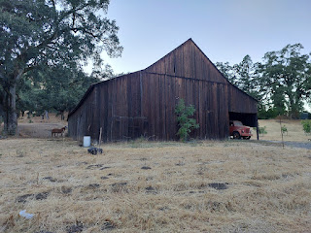

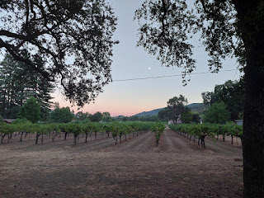

Friday, August 16th:

Time to say goodbye yet again, this time to my momma. We had some good times together, both with a packed house (incl. my daughter and her family, plus my sister and her son, plus Ryan's family) and also some quieter days. Interestingly, the older I get, the more I crave the quieter days. They refresh and replenish me. I'm so grateful, though, to have found some precious photos and poems that will remind me of the love my mother has for me. She has such a big heart and is so good with words and expressing her feelings. I'm so grateful, too, that I was able to be in the temple with her and to see firsthand the joy that she felt when she was sealed to her family. What a beautiful and precious experience!

I hit the road around 7:30 a.m. and drove straight to Portola, CA to see my 82 year old cousin, Valorie Sappingfield. She is a self-professed "hippie" and does not have internet or a smart phone so as to avoid the federal government, LOL. She was eager to see photos and hear stories about our recent Rawles Reunion, though, which I happily shared with her. She also needed to talk openly about her life in great depth with someone who had willing ears to listen and who could relate in certain ways to some of the hard things she's gone through. It was a bit much at times, and I'm never a fan of hearing someone use the F-bomb in a personal conversation, but I tried to just let her get it all out and to focus on being a friend by listening to her.

By the time we finished our visit, including a late lunch at the local Mexican restaurant that we frequent each summer when I pass through (Rico's), I was ready for some comforting silence in the car for a while. I know she won't be around much longer, because she's slowly and quietly dying of cancer. Her breast cancer has returned, and she doesn't want to go through the yucky chemo treatments. She prefers to just let nature take its course, however long or short that ends up being. She is a strong woman, and she's also a caring and wise woman. She is the one who is always thinking of others and sending them cards and notes in the mail. She calls many of her first cousins on a regular basis just to check on them. Sadly, she doesn't get as many responses as she would like, and even I haven't been writing her as often as I used to. I will try to do better!

I took a picture of her living room before I left . . . with all of the simple things she's collected during her long and colorful life.

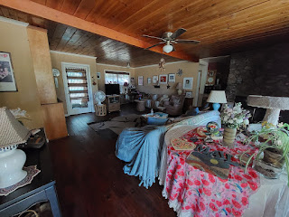

And out of respect for her - knowing that she isn't crazy about having her picture taken anymore, I took one from behind this time as she carried something out to the car for me.

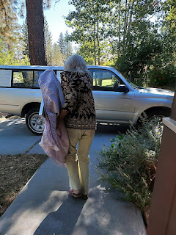

She gave me a special framed piece of art that she felt impressed to pass on to me: a photo of an old-fashioned thick window pane sitting above a patch of purple irises. It's really quite lovely and instantly reminded me that my Grandma Zoe's favorite flower was a purple iris. Valorie told me that her mother, Mary's favorite flower was also the purple iris. (Zola and Mary were sisters)

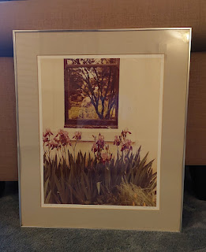

This photo was taken by a professional photographer in the 1970's and Valorie originally bought it as a gift to her mother, Mary. When her mother passed away several years ago, Valorie brought it home, and now she is passing it on to me. I feel very honored.

Saturday, August 17th:

After staying in a mediocre hotel in Lovelock, Nevada, I had 7.5 hours of driving to get the rest of the way home. I finished listening to the third book of Harry Potter (Prisoner of Azkaban), and I'm already looking forward to listening to the next one.

I drove through a FEROCIOUS storm between Twin Falls and Pocatello, with very strong winds (around 50 mph). I had two hands firmly gripping the steering wheel, too petrified to take either one off even for a moment, and the wind was pushing and shoving me all over the place. I was so glad to be home and out of the car once I finally arrived!

Amber and Weston drove back to Idaho Falls at the same time, but they beat me by a few hours. They came home to collect the rest of their stuff, but also to spend some time with Weston's family one more time. His parents are getting ready to serve their first mission together and they've been assigned to the Santa Rosa CA Mission!! Their specific assignment is to oversee the Girls Camp near Fortuna for the next two years and they are so excited!! They spoke in church Sunday morning and had a brunch at their house with lots of family and friends afterwards.

While Amber and her family were visiting in Rigby Saturday evening, I went to the GYM!! It was AMAZING. I haven't been to the gym for a couple of weeks and I really missed being there. I hopped on the treadmill and watched a show on Netflix on my phone while I exercised on a decent incline. It felt so awesome.

Sunday, August 18th:

Amber and Weston attended church in Rigby, while I worked on some things around the house in the morning and then went to my own ward at noon. They came back to my house around 1:00 p.m. and I slipped out of church after Sacrament meeting to meet them there.

I helped a little here and there with the packing and loading, but mostly they did it all and I was just a really good supervisor and cheerleader. We found our old car-top carrier in the garage and Weston figured out a way to strap it onto their roof. They packed as much stuff as they could fit into their trunk and into the carrier, but it still wasn't everything . . . sigh. I didn't realize there would be so much stuff still, or else maybe we could have packed a few more things when we caravan'd up to Oregon 2 weeks ago.

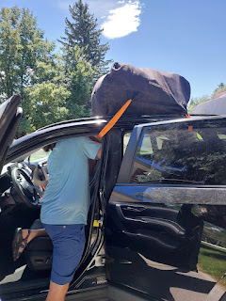

They left around 2:30 p.m., with their cat Broski all harnessed up for whenever they needed to stop at a rest area and attach his leash to let him stretch his legs a little. His annoyed expression says it all.

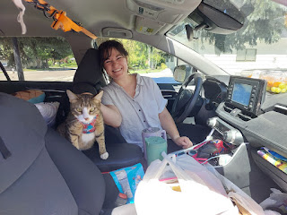

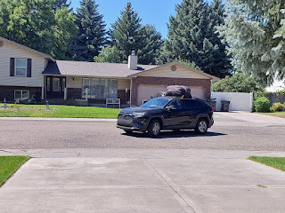

With the luggage on top, acting as a giant parachute, they got a pitiful 20 mpg on the 10.5 hour drive up to Portland. Amber texted me (and Weston's mom) later that night, around 9:00 p.m. with the following jolt:

"Stopping in Baker City to fill up. Almost ran empty . . . had 3 mi range when we pulled in. We did the math on the other side of Boise and we were going to make it, but then the hills ate up more of our gas and our miles of "wiggle room" decreased from 30...to 20...to 10...to 5...to 1...then Weston was able to switch the gears and coast downhill for a long ways and we gained 2 mi back for our tank. Phew! Won't be cutting it that close again!"

YIKES! Oh my gosh. They were so lucky . . . I'm glad they are young and able to recover from such a whirlwind weekend. They made it safely home around 2:30 a.m. Idaho time (1:30 a.m. Oregon time) and have been taking it easy today (Monday). Bless their little hearts. At least they are all together now and can get settled into their new life up in the Pacific Northwest.

Now, I am in the process of tidying up after the tornado came and left, ha ha. I am doing countless loads of laundry to wash all the bedding, and I'm working hard to get the house ready to lock up when I leave for Italy NEXT WEEK!!! My work list is LONG, but I put in several hours already today (Monday), tackling some tedious jobs. I spent the morning trimming the umbrella tree, trimming down some of the perennials (a.k.a. murdering them before the end of their season), cleaning up my huge mess, sweeping the garage, and switching the laundry every time I could.

Hope your week looks just as fun and inviting! Just kidding. I love to work. And I hope you have a great week. :)